# Homework 4 – Data Mining I – John Oehninger

## Text Description automatically generatedExercise 1

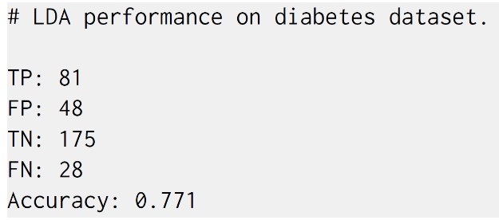1b)

1c)